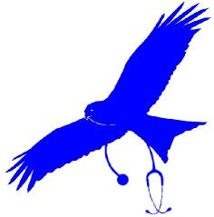
St Marnan Rd, Torphins, Aberdeenshire, AB31 4JQ

Torphins
Medical
Practice
Partners
Dr A Glennie
T: 013398 82221 F: 013398 89421
www.torphinsmedicalpractice.scot.nhs.uk

Dr L Ballantyne
Dr G Rutledge
Mrs K Reynolds
Salaried GPs
Dr G Thomson
Dr R Mercer
Dr W Mouat

ONLINE SERVICES
Repeat Medication Requests

We have an on-line secure service which will allow you to request repeat medication using the internet, at your convenience, even when we are closed. Prescriptions will be ready for collection 48 hours from the next working day.

The first step to access these services is to complete this form with your contact details. Once we process your request, you will receive an email containing details to allow you to register for the service and create a user name and password. This will be on an individual basis and a form and individual email address will be required for each family member. Children under the age of 16 are unable to use this service.

If you are interested in this service, please complete your details below and return this form to the practice.

Full Name:
Address:
Date of Birth:
Email Address:
Home Number:
Mobile Number:

Signature: _________________________________ Date: ______________

Please note that the email will come from a NOREPLY email address. If you do not receive it please check your junk folder.

